**Sql query**

# KPI

* **Total revenue**

SELECT sum(total_price) as total_revenue FROM pizza_sales;

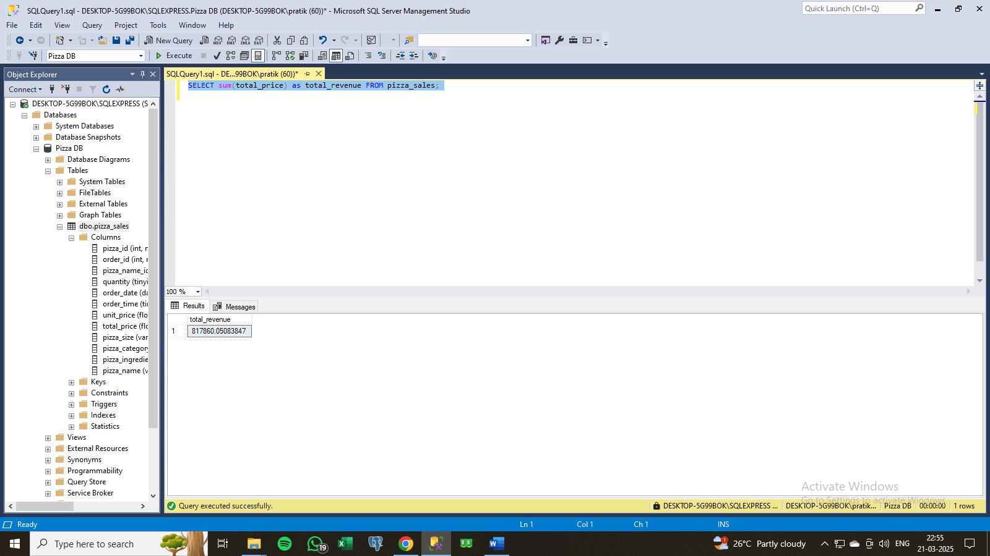

* **Average order value**

select (sum(total_price)/count(distinct order_id)) as average_order_value from pizza_sales;

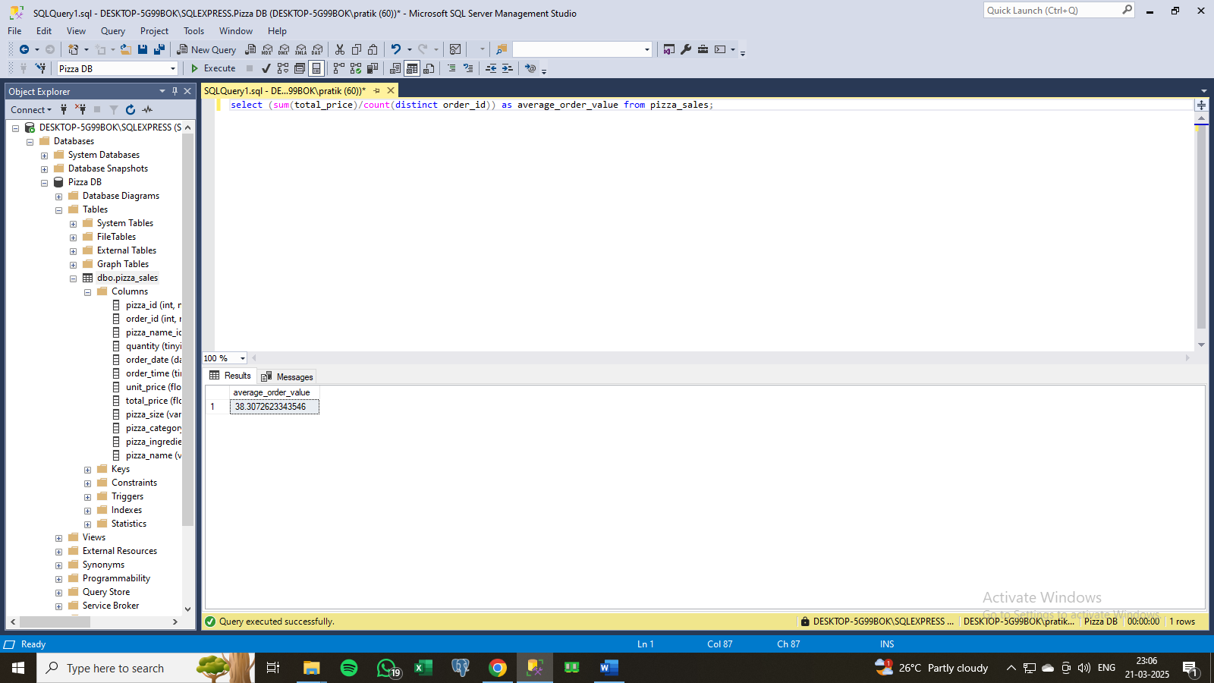

* **Total pizza sold**

select sum(quantity) as total_pizza_sold from pizza_sales;

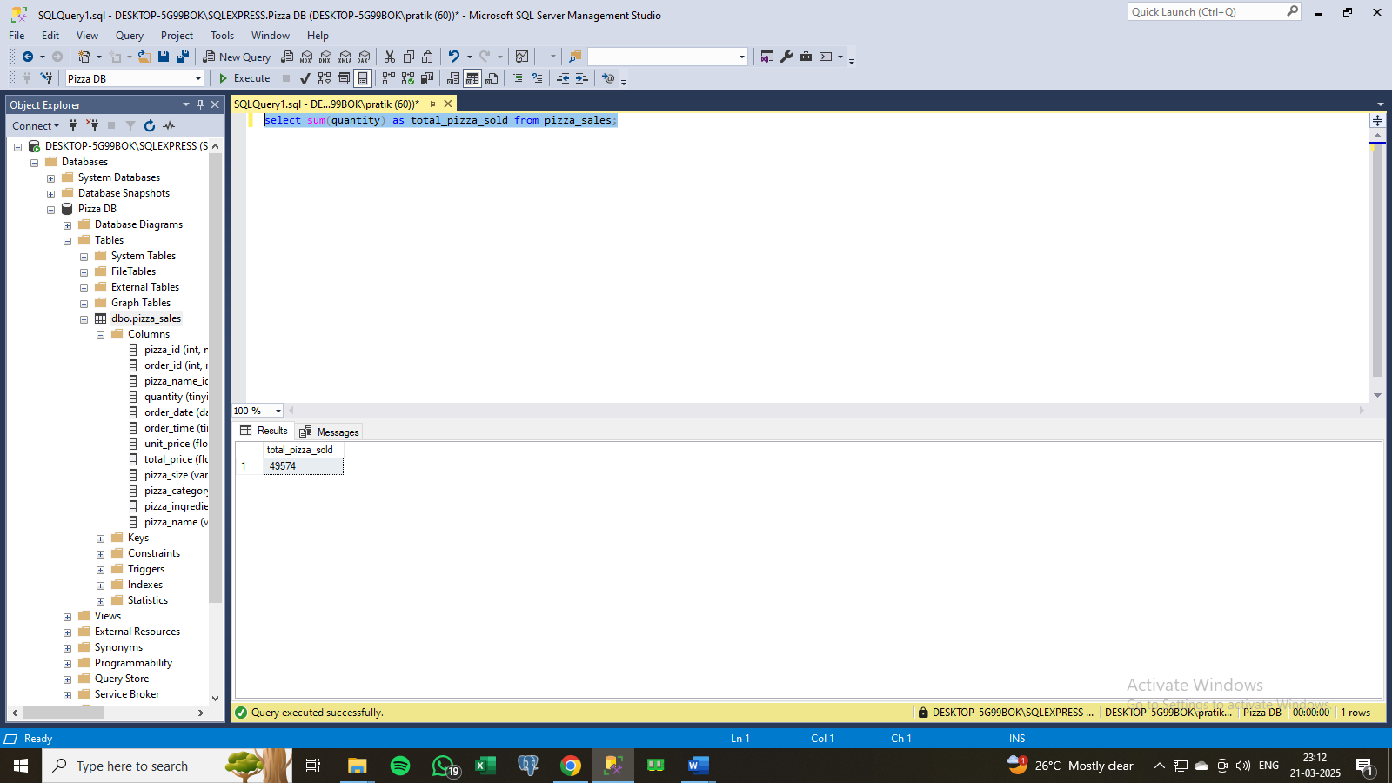

* **Total orders**

select count(distinct (order_id)) as total_orders from pizza_sales;

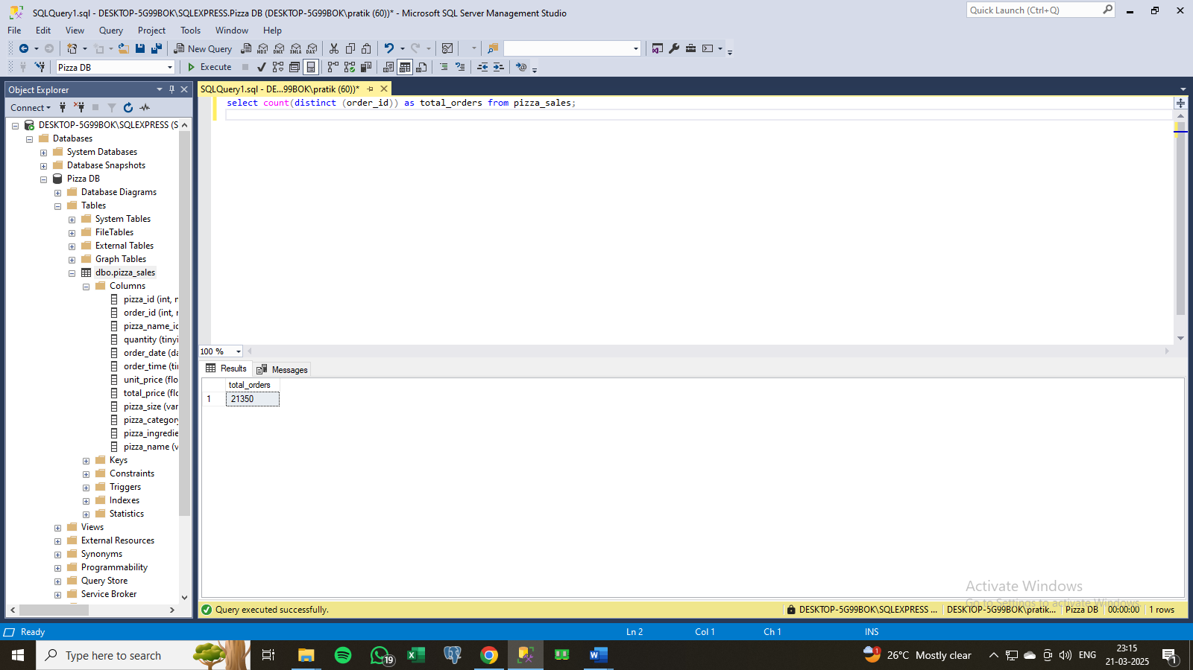

* **Average pizza per order**

select (cast (sum (quantity) as decimal (10,2))/

cast (count (distinct order_id) as decimal (10,2))) as average_pizza_per_order

from pizza_sales;

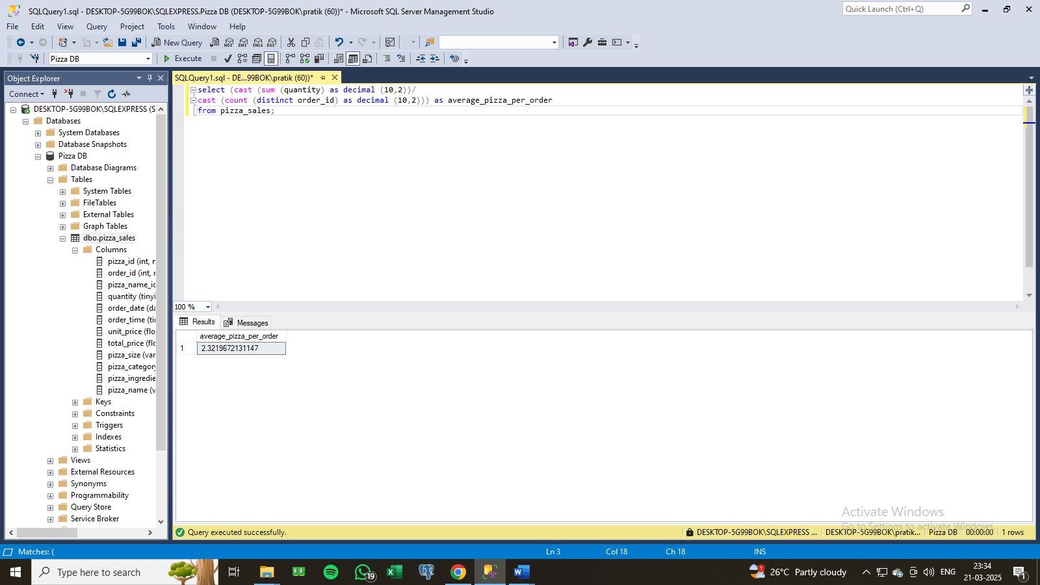

# Charts

* **B. Daily Trend for Total Orders**

select datename (DW, order_date) as order_day, count (distinct order_id) AS total_order from pizza_sales

group by datename (DW, order_date);

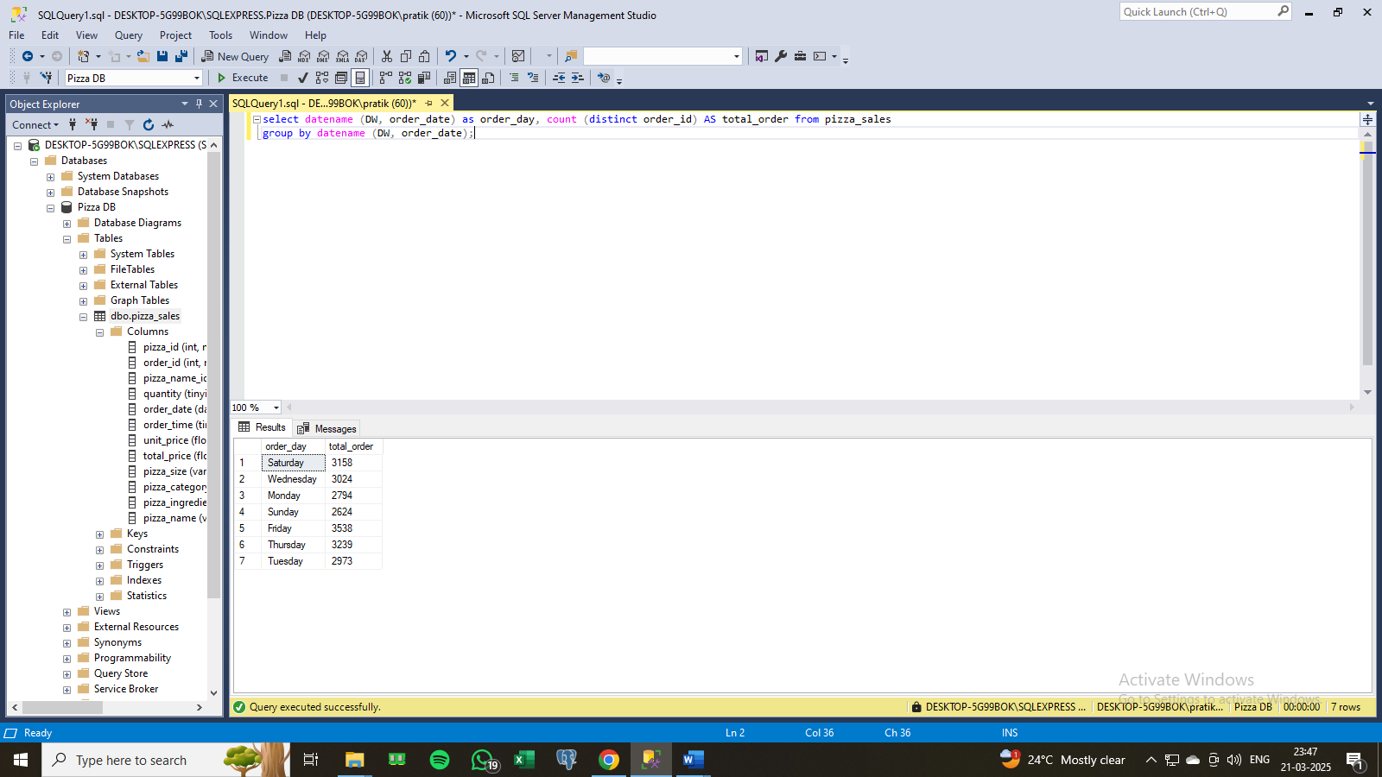

* **C. Hourly Trend for Orders**

select datepart (hour,order_time) as order_hour , count ( distinct order_id) as total_order from pizza_sales

group by datepart (hour,order_time)

order by datepart (hour,order_time);

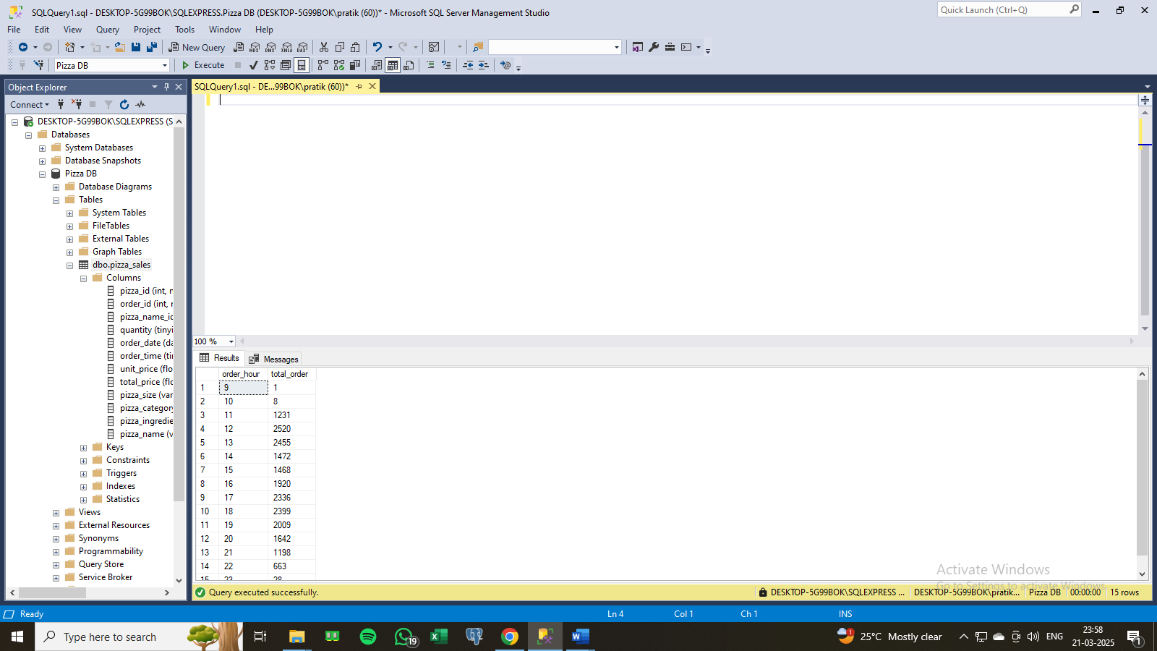

* **D. % of Sales by Pizza Category**

select pizza_category, sum(total_price)*100/(select sum(total_price) from pizza_sales) as total_sales

from pizza_sales

group by pizza_category;

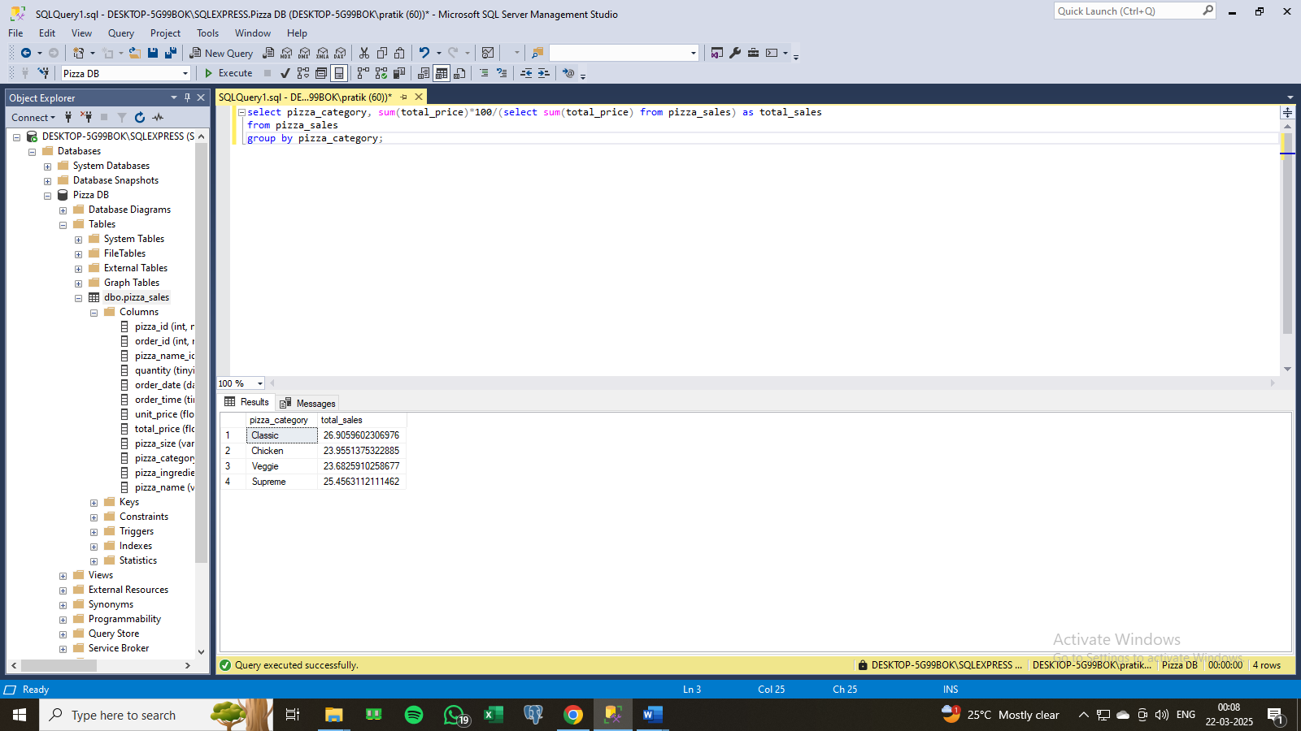

* **E. % of Sales by Pizza Size**

select pizza_size, sum(total_price)*100/(select sum(total_price) from pizza_sales) as total_sales

from pizza_sales

group by pizza_size

order by total_sales;

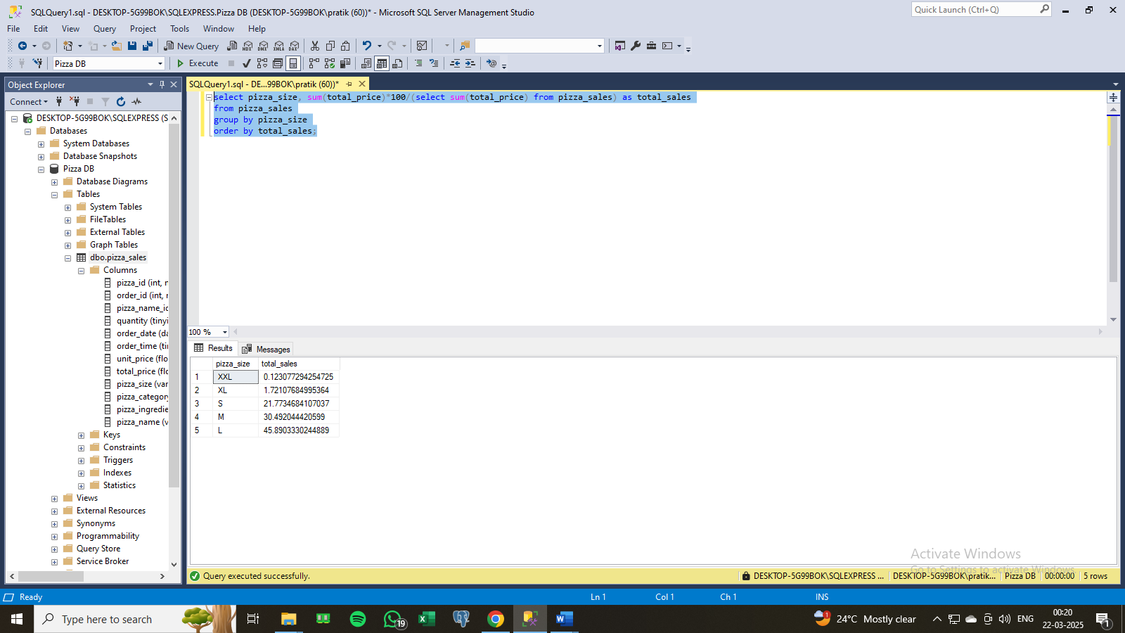

* **F. Total Pizzas Sold by Pizza Category**

select pizza_category, sum (quantity) as total_pizza_sold from pizza_sales

group by pizza_category;

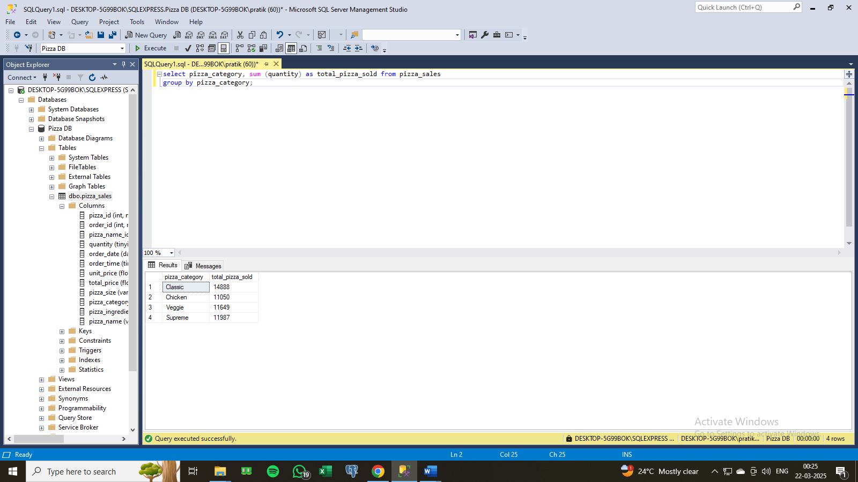

* **Top 5 Best Sellers by Total Pizzas Sold**

select pizza_name, sum (quantity) as total_pizza_sales

from pizza_sales

group by pizza_name

order by total_pizza_sales desc;

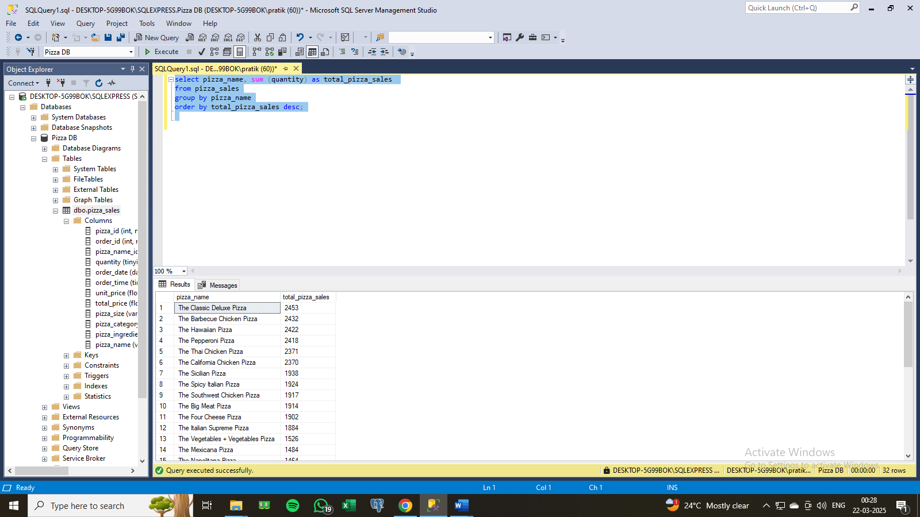

* **Bottom 5 Best Sellers by Total Pizzas Sold**

select pizza_name, sum (quantity) as total_pizza_sales

from pizza_sales

group by pizza_name

order by total_pizza_sales;

